1. What attribute is used to allow the new controller to respond to web API requests?

[ApiController]

1. How does the controller ensure that there is never an empty to do list?

Every time the constructor is used it checks if the todo list is empty and if so places a default value into it.

1. Run the app. Do 3 screen prints for all to do items, just item 1, and just item 2. Notice the difference in JSON for each response.

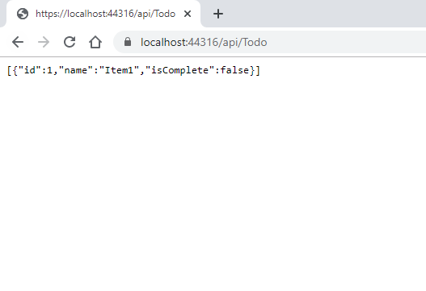

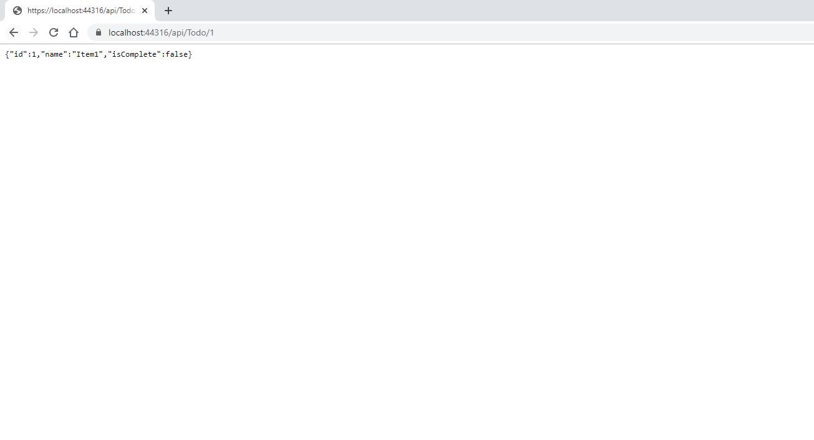

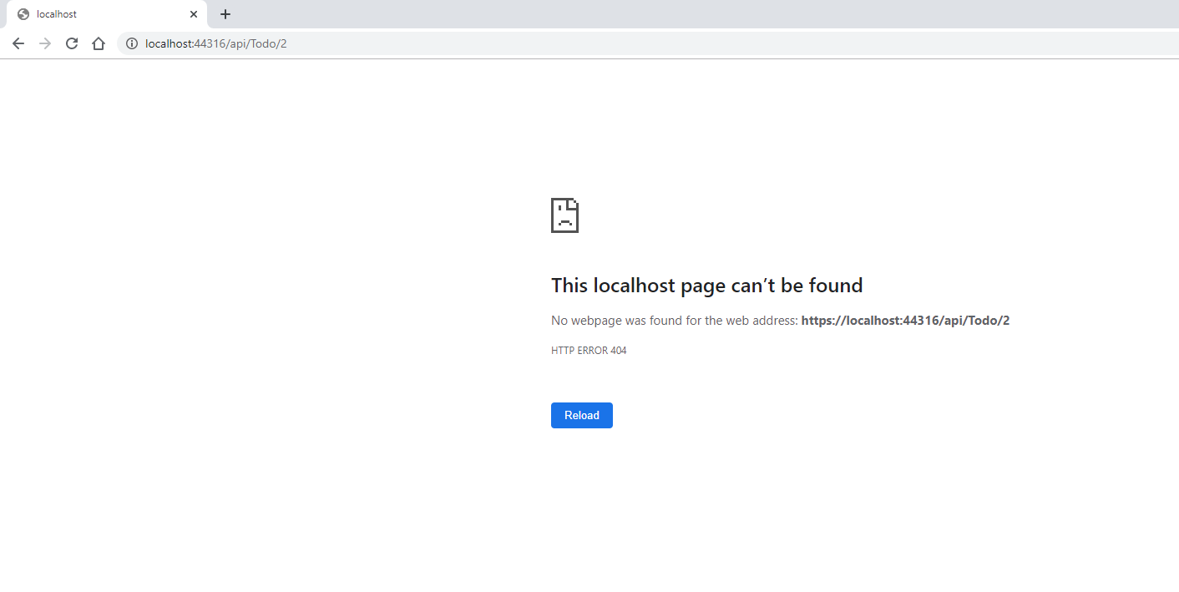

1. What attribute controls how the URL for the HTTP Get request is configured?

[HttpGet(“{ id }”)]

1. Briefly describe what a route template does.

The route template allows the program to auto fill the pathing to use a method by adding the controller name from the method only requiring it to specify it’s HttpGet string.

1. What is the return type from the HttpGet requests, and why is there a difference in the return type when requesting api/todo versus api/todo/1?

The return type of HttpGet request is ActionResults<T> type and there is a difference in return type because, the first request asks for a list of items while the second is only requesting one specific item.

1. What is the HTTP response code when an item(s) is found, and when not found?

404 when not found

200 when found

1. After installing Postman, do a screen print of a Get request.

